**Indian Institute Of Information Technology, Nagpur**

Course**: Waveguides and Antenna**

**Antenna report**

**NAME: Khirade Gaurav Ramesh**

**ENRL.NO: BT20ECE089**

**BRANCH: ELECTRONICS AND COMMUNICATION**

**Submitted To:**

**Dr. Paritosh Peshwe**

**Design of Koch-Dipole Antenna Using CST**

**Abstract** :

In this report, a simple **first iteration of the Koch fractal dipole antenna** has been designed and analysed for wireless applications. Resonant frequency for the dipole antenna was **1800 MHz** and as a simulation tool **CST** Microwave Studio has been used. After that the return loss curve, the VSWR and the far-field radiation patterns of the **Koch dipole antenna** have been observed.

Index Terms—Dipole Antenna, S-Parameter, Gain, Directivity and CST studio.

**INTRODUCTION:**

A Koch-Dipole antenna is a simple antenna that normally consists of two metal rods, a terminal block and coaxial cable. The Koch Snowflake was created by the Swedish mathematician **Niels Fabian Helge von Koch**. In order to create the Koch Snowflake, von Koch began with the development of the Koch Curve. The Koch Curve starts with a straight line that is divided up into three equal parts. Using the middle segment as a base, an equilateral triangle is created. Finally, the base of the triangle is removed, leaving us with the **first iteration of the Koch Curve.**

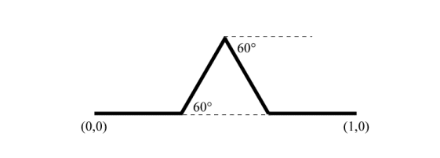

**ANTENNA DESIGN PARAMETERS :**

The basic structure of Koch dipole antenna is shown in the figure. A port is provided at the centre of the dipole and is fed by a voltage source. The proposed antenna is designed at a resonant frequency of 1800 MHz the antenna design parameters at 1800 MHz is given by:

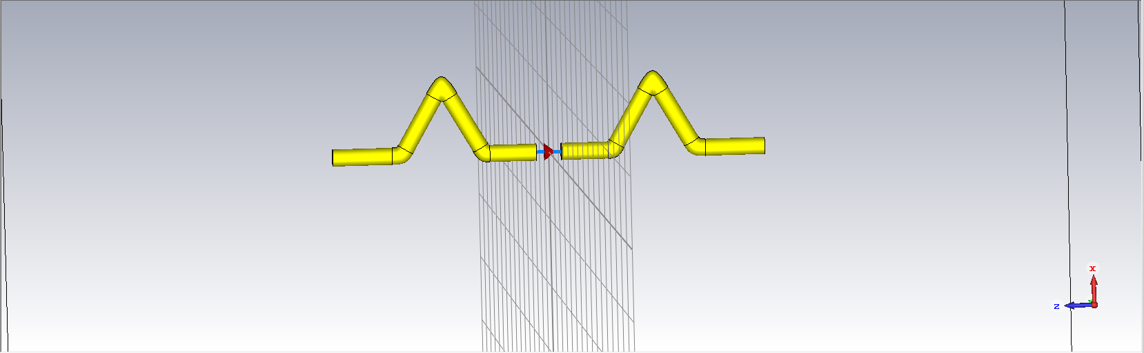

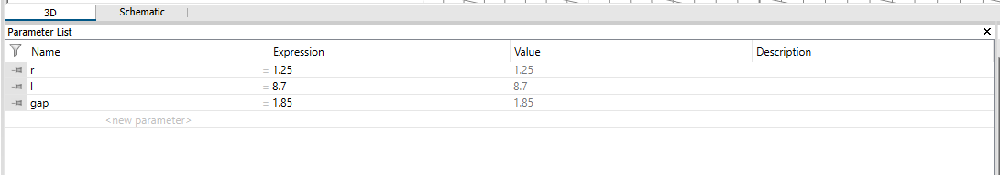

**Parameters List:**

**RESULT ANALYSIS:**

The proposed koch Dipole is simulated in CST Microwave studio. The optimized antenna design parameters have achieved improved gain and directivity.

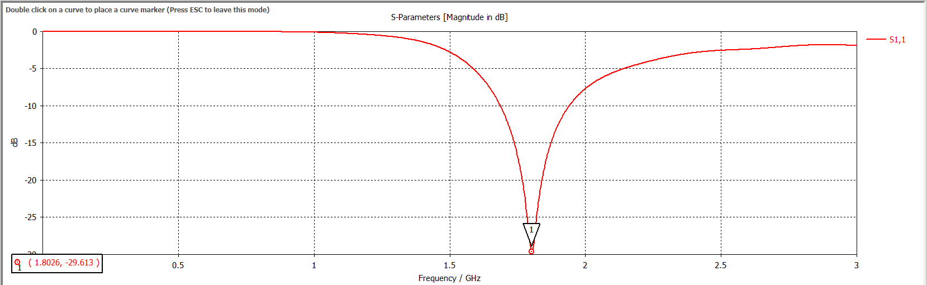

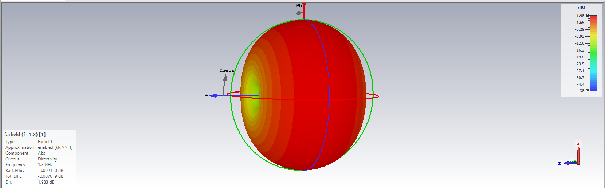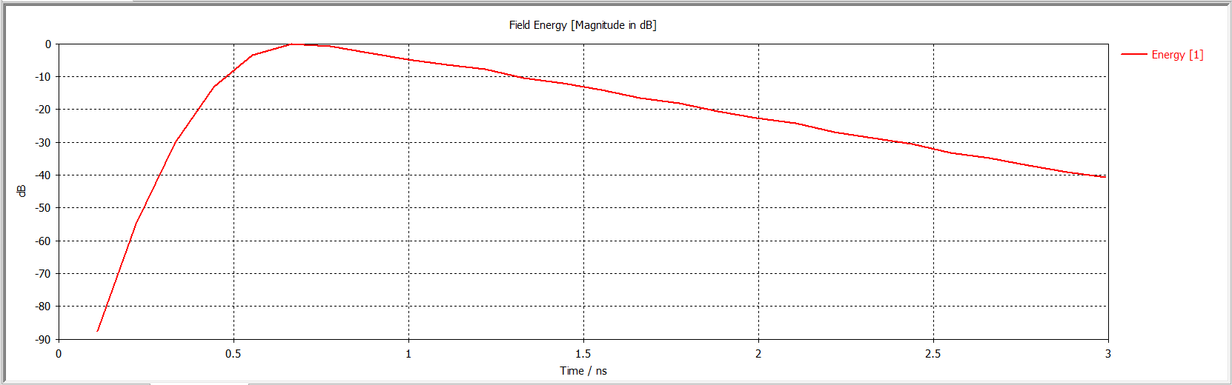

**Directivity :**

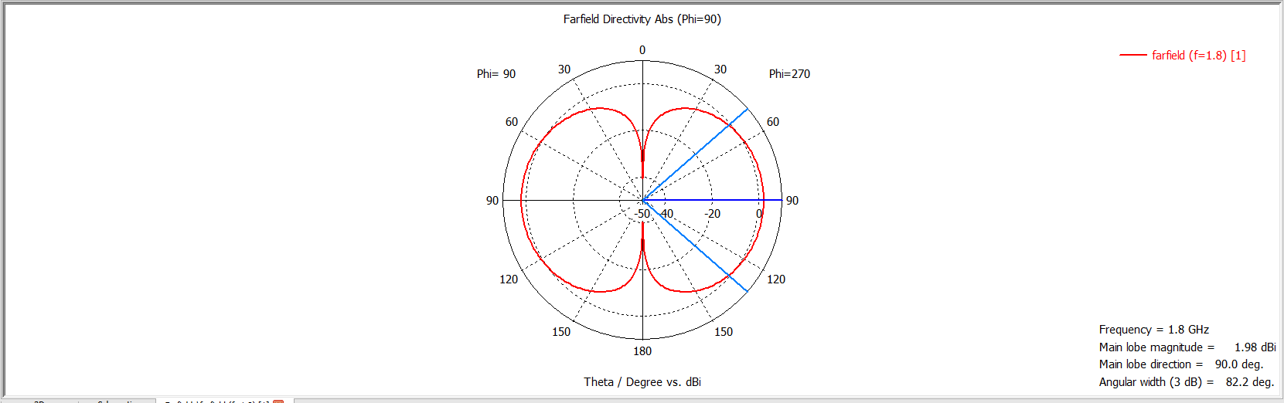

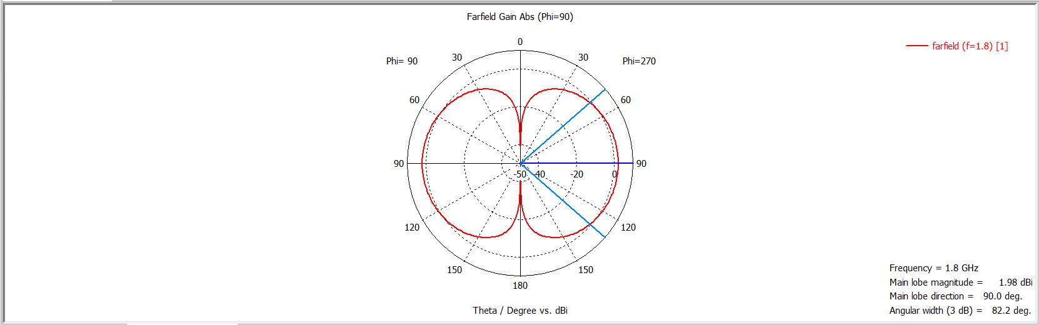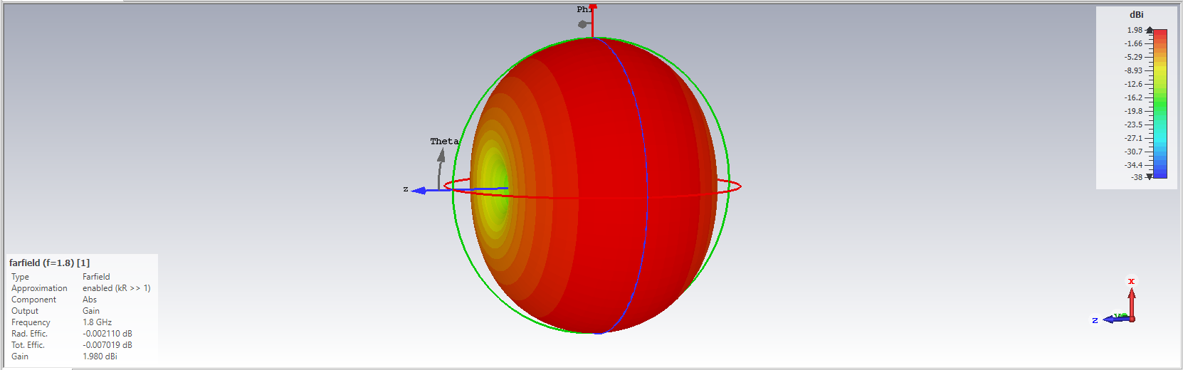

**Gain :**

**CONCLUSION :**

Main objective of this report was to observe the Koch Dipole antenna characteristics. Obtained results were acceptable for practical implementation of this type of antenna. As a simulation tool CST Microwave Studio was used which ease the simulation.

Obtained resonant frequency (1800 MHz) was lesser than target frequency (5 GHz) which is acceptable. Return loss obtained as 1.983 dB which shows the characteristic of Koch Dipole. There are few scopes to improve the results by optimizing several parameters which might be fruitful for researchers.